1-2 Thessalonians: Waiting for the Second Coming
The overall theme of both letters to the Thessalonians is how we are to live as we wait for the Second Coming of Jesus. Each chapter of 1 Thessalonians ends with a reference to the Second Coming, and 2 Thessalonians is even more focused on waiting and preparing for Judgment Day. Paul pointed to the Second Coming as an encouragement for the Thessalonians in their time of suffering. Though they had to endure persecution in this life, they could look forward in hope to vindication at Judgment Day and an inheritance in heaven. At the same time, he encouraged them not to just sit around and wait for the Second Coming, but to work hard at both their daily tasks as well as the mission of the Church as they waited in hope.
Author, Audience and Date
In both 1 and 2 Thessalonians, Paul opened the letters as being from himself, Timothy, and Silvanus. This doesn’t mean they were actually co-writers of the letter, but that they were with Paul as his ministry team. Both men were with him when he wrote, and they had both been with Paul as his co-laborers in the Gospel when he was in Thessalonica. Because Paul’s name is first, and he spoke in the singular elsewhere in the letter (e.g., 3:5), he was the actual writer of the letter. Silvanus was his amanuensis and Timothy was his most-trusted helper. Paul sometimes wrote with a “we” as well, to include Timothy and Silvanus in his thoughts, as his ministry team, in the same way our senior pastor might write a letter to the church, but use “we” and sign it as being from the whole ministry team.
Timothy was one of his “sons of the faith,” a pastor he trained, mentored, and then left in various churches to train and mentor other leaders. If you remember from our study on 1 and 2 Peter, Silvanus had served as Peter’s secretary. He did the same for Paul with these two letters. It was very typical for ancient writers, academics and apostles to use an amanuensis – the Greek word for “a literary secretary.”
Paul wrote 1 and 2 Thessalonians from Corinth during his second missionary journey in AD 49–51. He and his companions had established the church in Thessalonica but were forced to leave there by opponents of the Gospel (Acts 17). Later, Paul sent Timothy back to Thessalonica to check on the church there. Timothy came back with a report on their struggles with persecution and the unexpected death of some members, which had shaken their hope. Paul responded with 1 Thessalonians. Shortly after writing the first letter, Paul received another report that the Thessalonian church had accepted a strange false teaching that the day of the Lord had already come (2 Thessalonians 2:1–2), so he sent them a second letter right after it.
The capital of Macedonia, Thessalonica was a prestigious and busy city located on the coast of the Aegean Sea on a natural harbor along the busy east-west Egnatian Way. Because of its location on the trade route, the city was prosperous and culturally diverse. It had a cosmopolitan population that included many different cultures with many different gods. They also had a large Jewish community, which is why when Paul and his companions went there, they were able to preach in the synagogue and tell a lot of people about Jesus very quickly. Yet, when Paul preached and some chose to follow Jesus, the Jewish leaders became jealous, formed a mob, and drove them out of the city. They accused the Christians of acting against the decrees of Caesar in declaring there to be another king – Jesus (Acts 17:1–9).
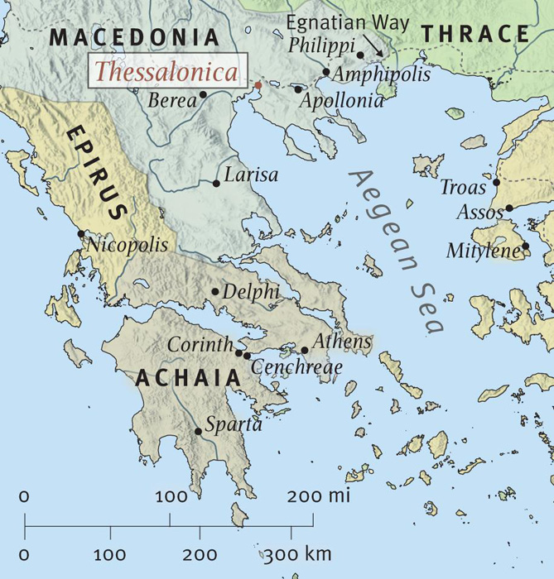
1 Thessalonians
1 Thessalonians was written in response to Timothy’s report that the Thessalonians were struggling to keep their hope and faith in the midst of persecution and the unexpected deaths of some of their church members. Paul wrote to remind them of the supernatural power and authority of the Gospel and the fact that persecution is normal for believers.
2 Thessalonians
This letter has a harsher tone than the first one. While 1 Thessalonians was warm, emotional, compassionate and reassuring, 2 Thessalonians swings between rebuke and encouragement. Second Thessalonians includes some blunt commands rebuking both bad behavior and bad theology. While Paul loved the Thessalonians, he wanted to be clear about rebuking the false teaching some of them had believed.

Thomas L. Constable, “1 Thessalonians,” The Bible Knowledge Commentary: An Exposition of the Scriptures, ed. J.F. Walvoord and R.B. Zuck, vol. 2 (Wheaton, IL: Victor Books, 1985) 690.
ESV Study Bible (Wheaton, IL: Crossway Books, 2012).
Mark Cartwright, “Thessalonica” World History Encyclopedia - https://www.ancient.eu/Thessalonica/
ESV Study Bible (Wheaton, IL: Crossway Books, 2012).

